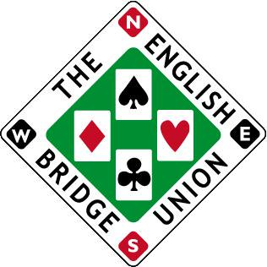

Entry form for the EBU Spring Bank Holiday Congress 27-29 May 2023
Event being held at the Crowne Plaza Hotel, Reading

Saturday/Sunday 27/28th May – Two Star Pairs

Player 1: EBU number:
Player 2: EBU number:

Monday 29th May – Swiss Teams

Player 1: EBU number:
Player 2: EBU number:
Player 3: EBU number:
Player 4: EBU number:

Saturday 27th May - Jack High Swiss Pairs

Player 1: EBU number:
Player 2: EBU number:

Sunday 28th May – Two Star Consolation Swiss Pairs

Player 1: EBU number:
Player 2: EBU number:

Phone number:
Email address:

Price List (per person)
- Two Star Pairs & Swiss Teams £135 (Early booking £127 if paid by 28th February)
- Two Star Pairs £92 (Early Booking £87 if paid by 28th February)
- Jack High Swiss Pairs £30
- Consolation Swiss Pairs £48
- Swiss Teams £48
- Consolation Swiss Pairs & Swiss Teams £90 (£87 if paid by 28th February)
- Jack High Swiss Pairs & Swiss Teams £75
Please select option a-g and then transfer fee to sort 404230 account 72143569 acct name Oliver Cowan. If paying by cheque, please send to Oliver Cowan, 6 Sandringham Drive, Moortown, Leeds, LS17 8DA
If you wish to pay using EBU credit, please speak to the accounts department at the EBU and they can arrange for payment using credit.
Bed & Breakfast per night £140 single occupancy £150 double/twin. Put a note on the email when submitting the entry form and add the cost of the room/s when making payment and you room will be booked for you. Alternatively, call the hotel and quote reference ‘H1C’ if you wish to book yourself. Bedrooms are limited and these prices are guaranteed until 26th April. There are obviously other hotel option in the area.
Completed entry forms should be sent to ocbridgecomps@gmail.com
Closing date for entries Friday 19th May 2023

