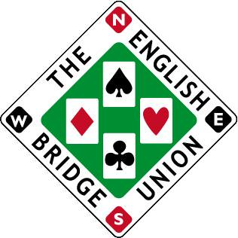
Entry form for the EBU Scarborough Summer Congress 18-21 July 2024
Event being held at the Crown Hotel & Spa
Thursday 18th July – Category Pairs
Player 1: EBU number:
Player 2: EBU number:
Friday 19th July – Multiple Teams
Player 1: EBU number:
Player 2: EBU number:
Player 3: EBU number:
Player 4: EBU number:
Saturday/Sunday 20/21st July - Swiss Pairs
Player 1: EBU number:
Player 2: EBU number:

Phone number:
Email address:
Price List (per person)
- Full congress £140 (Early booking discount £132 if paid by 30th April)
- Multiple Teams & Swiss Pairs £108
- Category Pairs £36
- Multiple Teams £41
- Swiss Pairs £72
- Category Pairs & Multiple Teams £72
- Category Pairs & Swiss Pairs £105
Please select option a-g and then transfer fee to sort 404230 account 72143569 acct name Oliver Cowan. If paying by cheque, please send to Oliver Cowan, 6 Sandringham Drive, Moortown, Leeds, LS17 8DA
If you wish to pay using EBU credit, please speak to the accounts department at the EBU and they can arrange for payment using credit.
To book a bedroom at the Crown Hotel & Spa, please call them direct on 01723 357400 (option 2) and quote “bridge” for discounted rates.
Completed entry forms should be sent to ocbridgecomps@gmail.com
Closing date for entries Friday 7th July 2024

