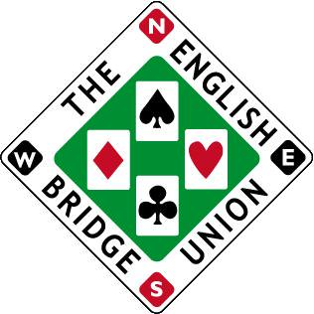

Entry form for the EBU Spring Bank Holiday Congress 25-27 May 2024
Event being held at the Crowne Plaza Hotel, Reading

Saturday/Sunday 25th/26th May – Two Star Pairs
Player 1: EBU number:
Player 2: EBU number:

Monday 27th May – Swiss Teams
Player 1: EBU number:
Player 2: EBU number:
Player 3: EBU number:
Player 4: EBU number:

Saturday 25th May - Jack High Swiss Pairs
Player 1: EBU number:
Player 2: EBU number:

Sunday 26th May – Two Star Consolation Swiss Pairs
Player 1: EBU number:
Player 2: EBU number:

Phone number:
Email address:

Price List (per person)
- Two Star Pairs & Swiss Teams £142 (Early booking £136 if paid by 28th February)
- Two Star Pairs £98 (Early Booking £93 if paid by 28th February)
- Jack High Swiss Pairs £30
- Swiss Pairs £51 (Consolation, free to those not qualifying for Two Star Pairs final)
- Swiss Teams £51
- Swiss Pairs & Swiss Teams £96 (£92 if paid by 28th February)
- Jack High Swiss Pairs & Swiss Teams £75
Please select option a-g and then transfer fee to:
Sort code 404230
Account number 72143569
Account name Oliver Cowan
If paying by cheque, please send to Oliver Cowan, 6 Sandringham Drive, Moortown, Leeds, LS17 8DA
If you wish to pay using EBU credit, please speak to the accounts department at the EBU to arrange for payment using credit.
Bed & Breakfast per night £145 single occupancy £155 double/twin. Put a note on the email when submitting the entry form and add the cost of the room/s when making payment and you room will be booked for you. Alternatively, call the hotel and quote reference ‘FP9’ if you wish to book yourself. Bedrooms are limited and these prices are guaranteed until 26th April. There are obviously other hotel options in the area.
Completed entry forms should be sent to ocbridgecomps@gmail.com
Closing date for entries Friday 17th May 2024, early booking is advised.

