Anytown Bridge Club

If you enjoy playing bridge come and join us

insert day & time
insert venue

Each session costs just £x (non-members £x)
including refreshments (delete if not appropriate)

♠ ♥ ♣ ♦

We welcome duplicate bridge players of all standards, from novices to experts, with or without a partner – our host system means  you should always get a game! | 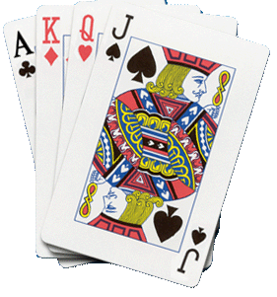

♠ ♥ ♣ ♦

To find out more, please contact:
Insert person on 0xxxx xxxxxx or email x@x.com
www.anytownbridgeclub.org.uk

Anytown Bridge Club is affiliated to the English Bridge Union

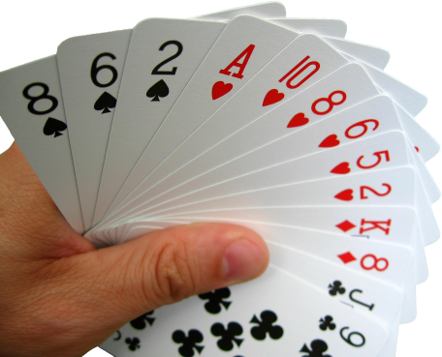 |  | 