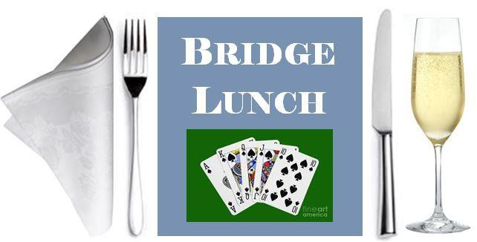Bridge Lunch at XXX Bridge Club

Venue
Date

Please join us for an afternoon of
Bridge
preceded by a
Reception and lunch

You are invited to arrive from xxx at xxx to e.g. roam the beautiful gardens and lakesides, visit the gift shop and purchase tea/coffee from the café/bar

Please note: All playing requirements will be provided
Early application is recommended
Tables (4 places) are £xxx or £xx per person

Please address any inquiries to: Xxxxxxx

