xxxxx Bridge Club

XXX Bridge Club Phone Number xxx
Free Bridge Taster Session
Date Time
Have you ever considered learning to play bridge but are too nervous or shy to try? Do you enjoy playing cards and wonder if you’d enjoy playing bridge?
Would you like to develop a new hobby which will keep your mind active
Perhaps you’ve recently retired and have more free time?
Would you like to make new friends and join a friendly and supportive Bridge Club?
Come along to our free taster session, enjoy a coffee and cake, and we’ll introduce you to our club, and give you the chance to play a simplified form of bridge. Please register your attendance by either phoning the club or sending an email to xxxxxxx
If you already play some bridge and would like to improve or play more competitively come along to our friendly classes. We can help in determining which lessons would suit you best. Either come along to the taster session or send an email to xxxxx
The xxxxx Bridge Club offers bridge lessons at all levels with tournaments suitable for new players. Take a look at our website for more information:
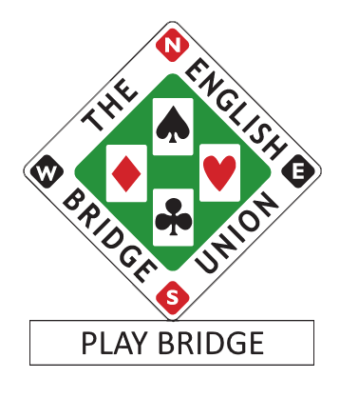
www.anybridgeclub.com

