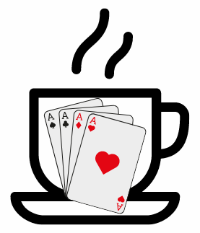
Anyclub Café Bridge

Date

You are invited to join us for a fun, relaxed day, playing friendly duplicate bridge in a variety of cafes within easy walking distance of each other. The venues include; Café 1, Café 2, Café 3

The event starts at time with tea/coffee and a pastry at Café (directions to venue), when you will receive your playing instructions for the day, before heading off for your first venue. If you are not familiar with the area don’t panic, you will be provided with a map. You will play X rounds of bridge before eating lunch in the venue where you play the 3rd round. After lunch there will be 2 further rounds of bridge, with play ending around time when you will head back to venue for a glass of wine and the results.

Cost for the day is £xx each. This includes tea or coffee with a pastry at the start, lunch, a glass of wine at the end and prizes. This is payable by xxx to Any Bridge Club when you book your place.

ALL PROFITS WILL GO TO CANCER RESEARCH UK

Entries are limited to xx pairs and will be taken on a first come first served basis.
Entries by date please.

For further information and entries please contact XXX and XXXX on

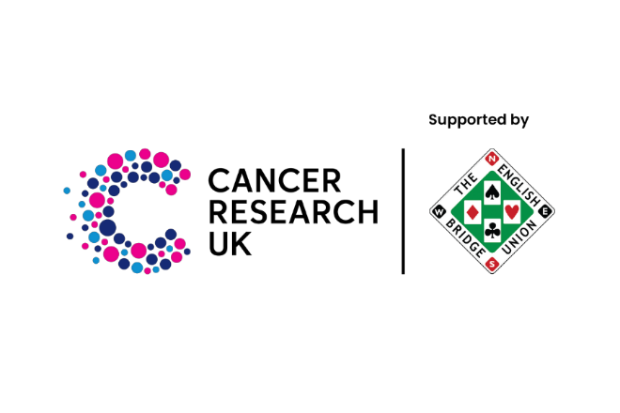
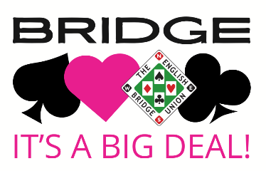
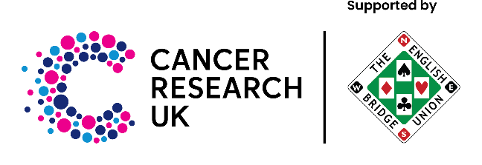
contact details

