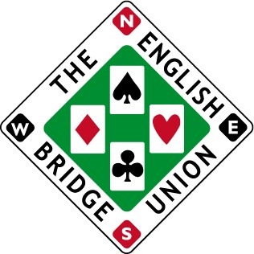
Application for a Licence
to organise a duplicate event
Please contact the appropriate County CBA, then send this completed form to: The Licensing Secretary
The English Bridge Union
Broadfields, Bicester Road

Aylesbury HP19 8AZ

Name of  Applicant : ....................................... | on behalf of :  (organisation, club, etc.) .........................................
Address : ...........................................................................................................................

...........................................................................................................................

...........................................................................................................................

...........................................................................................................................

...........................................................................................................................
Telephone : ...........................................................................................................................
Email Address : ...........................................................................................................................
Web Site (if available) : ...........................................................................................................................

EVENT DETAILS

Name of Event : .....................................................................................................................
Date of Event : …................................ | Type of Event :  (Swiss Teams, etc.) .........................................
Venue (town & county) : .................................................................................................................

Master Point type :  (green/blue or local) ..................................... | Status sought :  (club / district / county) .........................................
Significant entry from outside local area ? ............................... | Restricted to  EBU members ? .........................................
Name of proposed T.D. in charge :  …………………………………………………………. | Number of Boards :  ……………………………………………………………………

Please issue me with a licence for the above event.
I confirm that I have contacted the secretary of the appropriate County CBA, who has raised no objections. I confirm that entry from currently sanctioned players will not be accepted.
Signed : |  | ............................................................................. Date : .........................................

