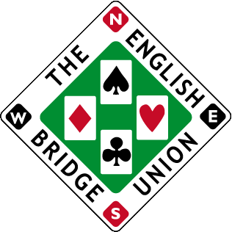

NOMINATION FORM FOR SILVER AWARD 2023

The Silver Award is given for outstanding contribution to the management/administration of the game at national and/or international level. Typically, this will have been evident for many years. Please note this now excludes any achievements relating to play and deals solely with administrative matters and the development of the game.

The criteria:

- Anyone who meets the purpose and criteria in making a significant contribution as a volunteer at National and/or international level.
- This will typically involve 10 years or more on the Board and/or Standing Committees.

Please provide name and details of nominee achievements using some or all of the criteria above.

Nominees Full Name:

Declaration

I confirm to the best of my knowledge that the information that I have provided in this nomination form is accurate and true.

Signature:

Date:

Nominated by:

:

Your nomination will be reviewed by the EBU Board of Directors, who will be in contact in due course within the parameters of the nomination process.

Please submit your nomination to kay@ebu.co.uk before: 25th August 2023

